**Note: frontend will be deployed on onrender.com as a static file and backend will be deployed as a webservice.**

First keep all ur react content ie., whole front end content into a separate folder .lets say – frontend folder.

Keep all the backend code –nodejs,express server and mongodb ,mongoose stuff into another folder – backend.

**Backend**:

First – deploy the backend website as a webservice.

Push whole backend code into github and open onrender.com and create a webservice.

Create a repository and Then push the whole front end code into a github repository .

Add gitignore file – add env variable for port , jwt secret etc

Add .env and nodemodules file in .gitignore

Then open render.com – <https://render.com/>

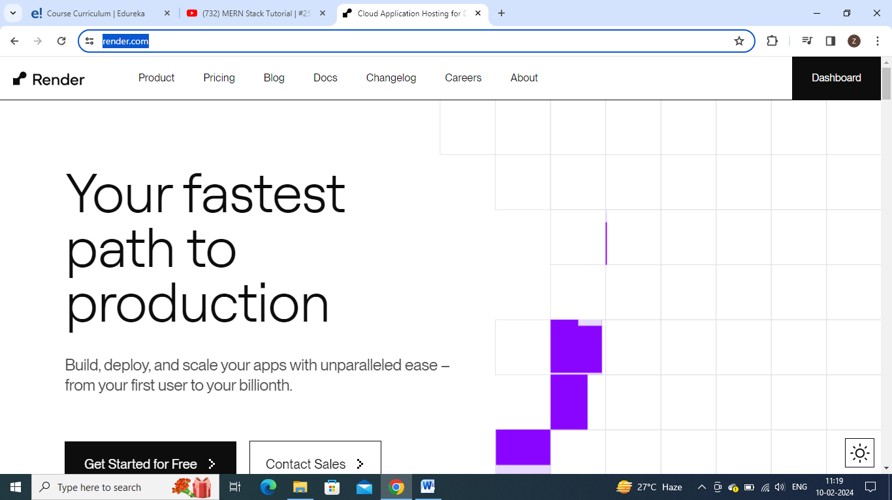

Go to dashboard

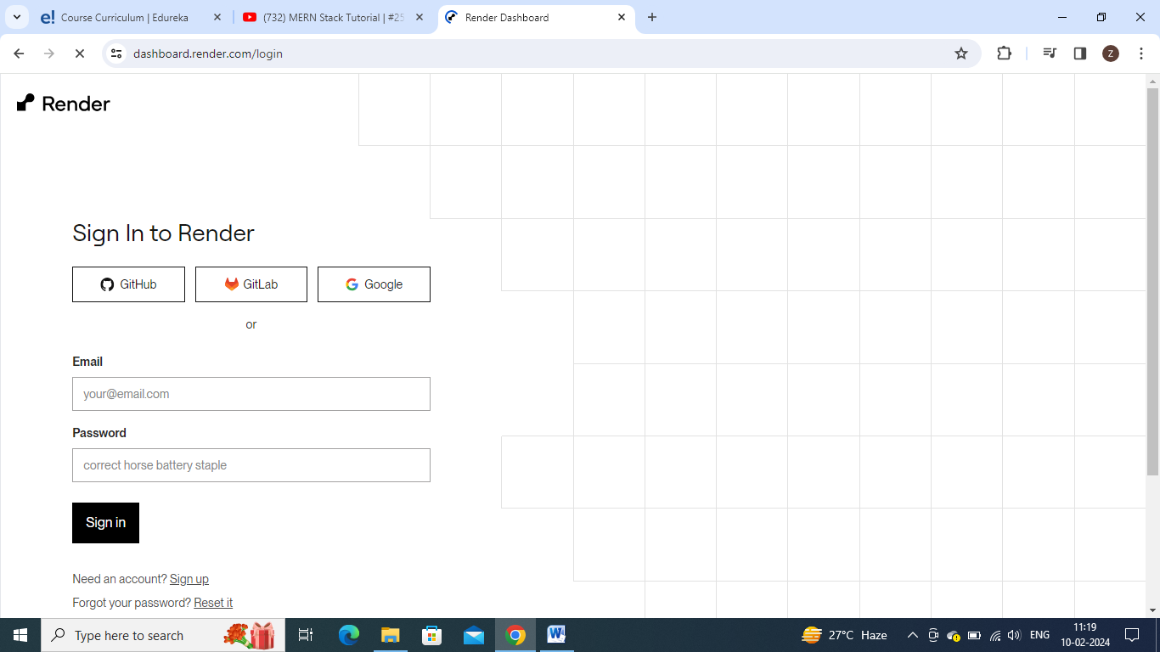

Signup and signin.

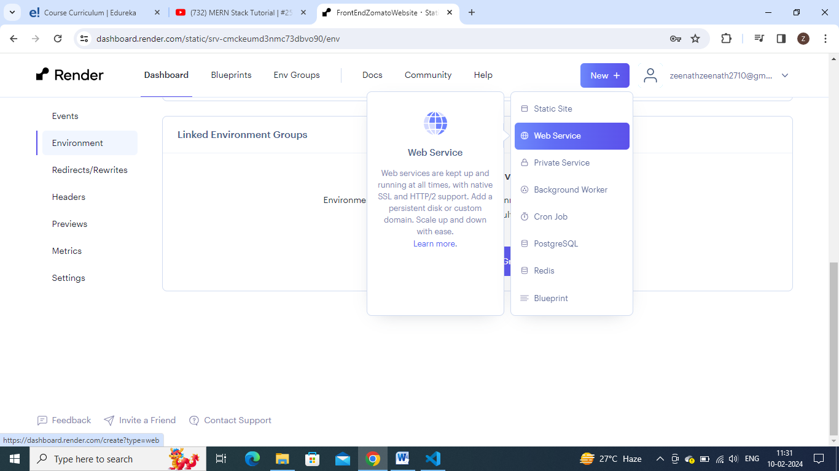

select as a webservice site.

Click new button and select web service

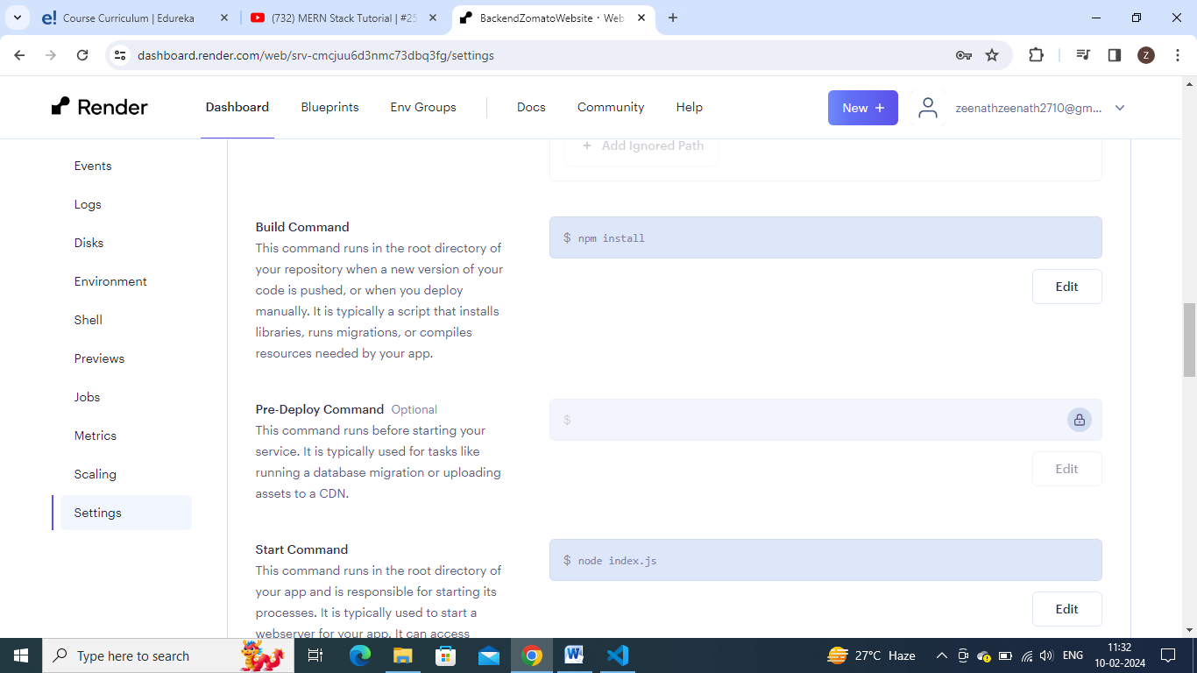

Give build command as npm Install and start command as node filename.js

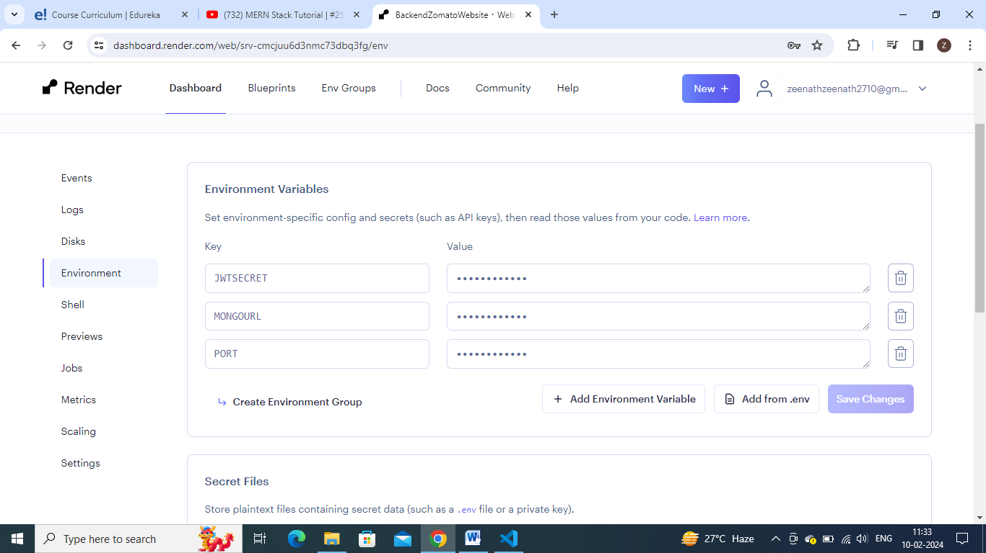

Add these env variables which are in .env file

Then click create webservice- it takes some time and then u get ur website is live.

**Frontend:**

Lets then deploy our frontend app- do npm run build – it will create a build folder inside it, this folder is comprised version of whole react app. It will be helpful while hoisting.

And if u are using vite app – means on dng npm run build in terminal – u get dist folder / instead of build folder

In react app- u get build folder on doing npm run build

Create a repository and Then push the whole front end code into a github repository .

Then open render.com – <https://render.com/>



Go to dashboard



Signup and signin.

select as a static site.

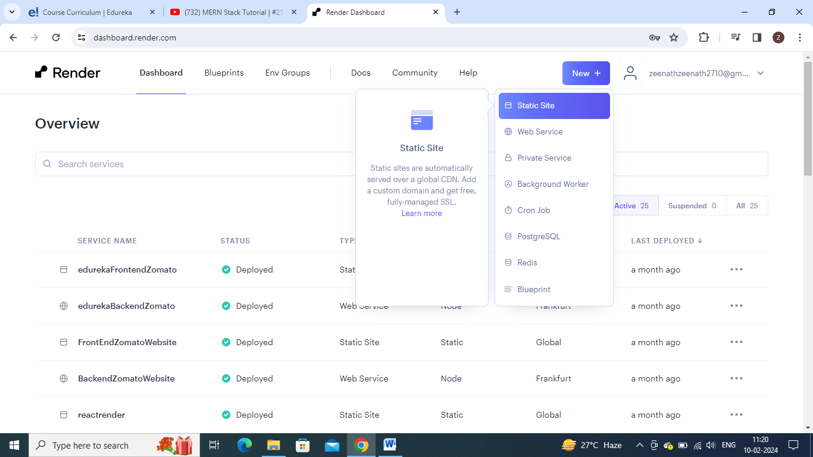

Click new button and select static site

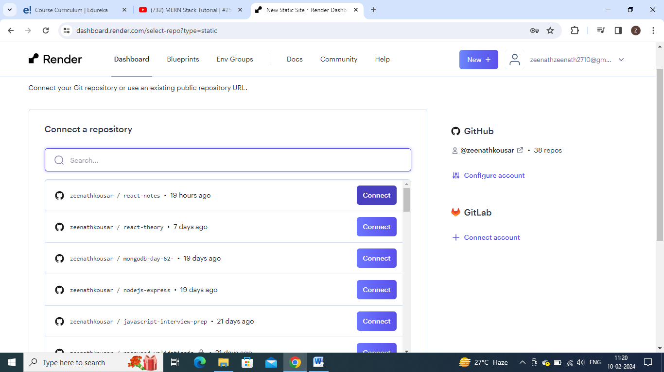

Connect to the respective frontend repository

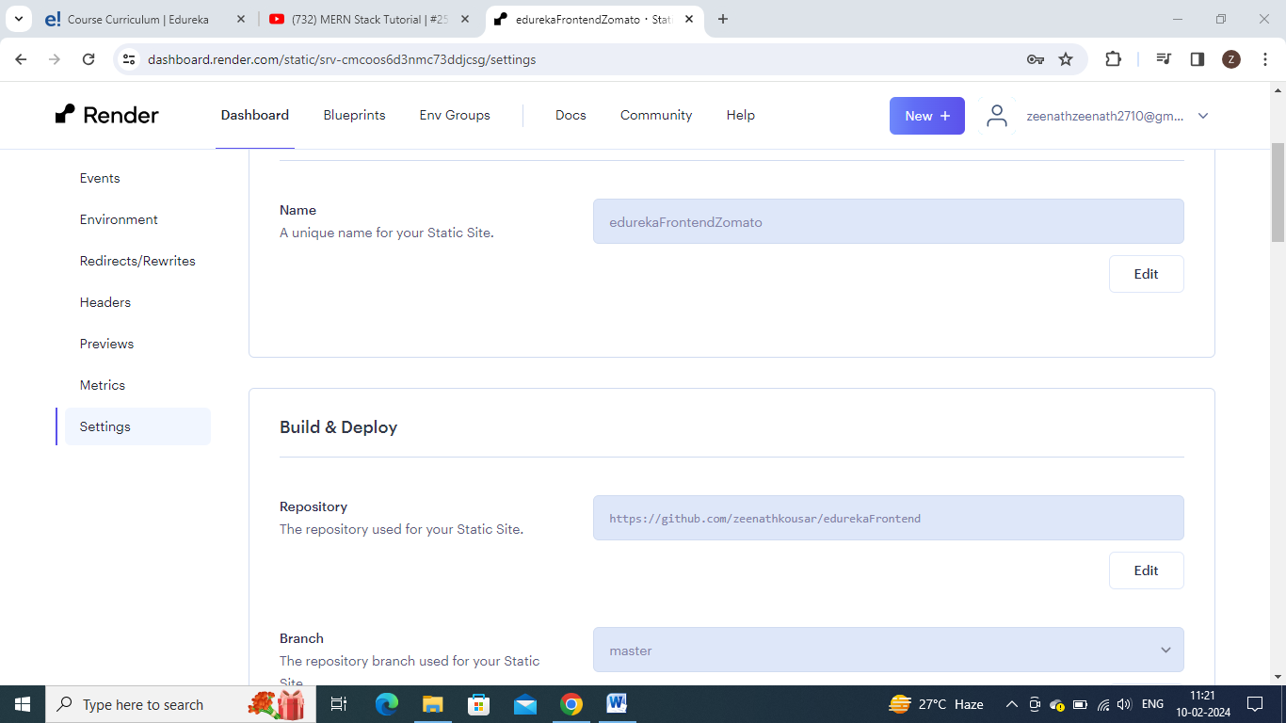

Then u can give any name to ur website

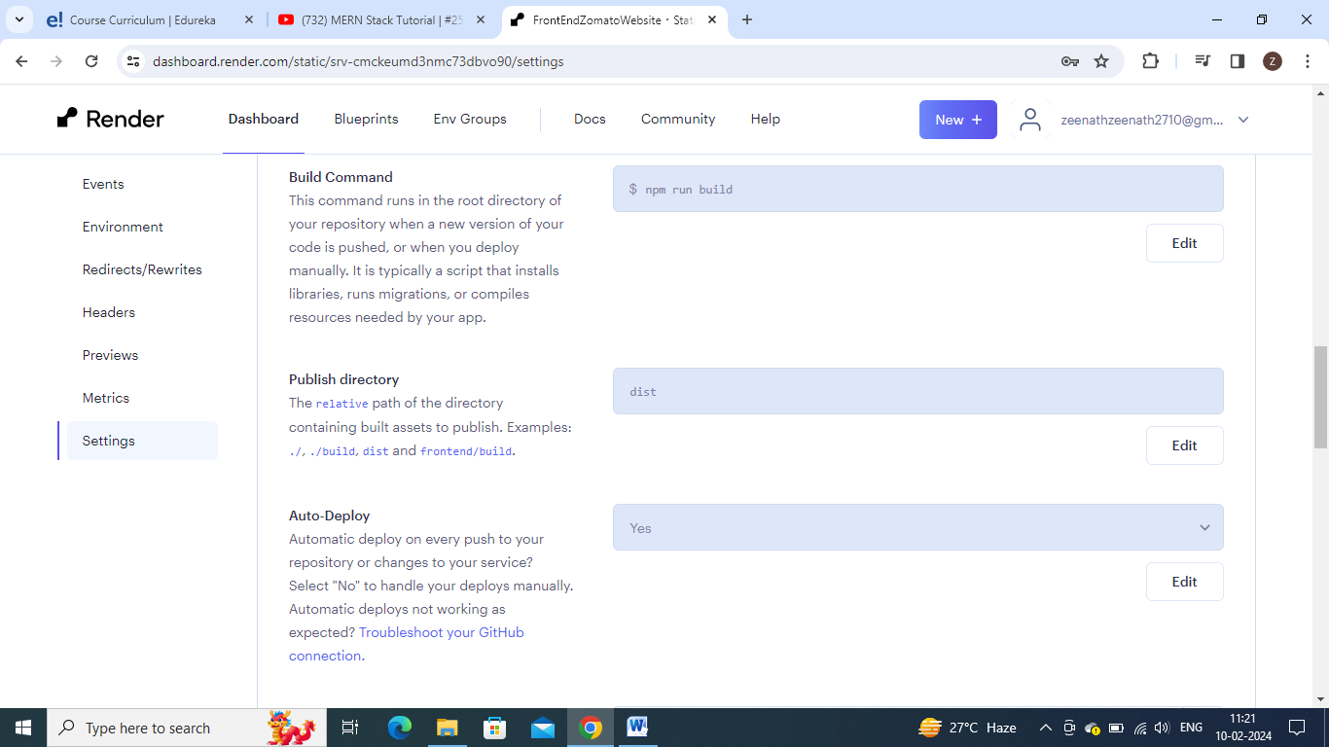

Enter build command as npm run build.

If ur app is vite app – give publish directory as dist.

If ur app is react app- give publish directory as build.

And in frontend of ur website – in .env file – u will have a variable with value localhost:port, this is the port in which ur backend may be working .

So before creating static file. Do add env variable . 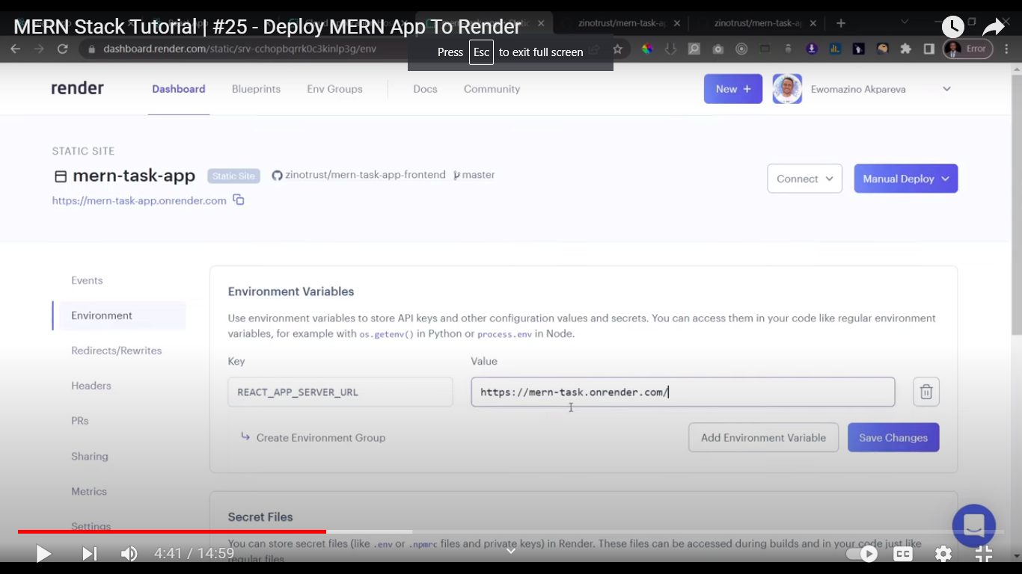

Here give the url of hoisted backend site.

Then click create static site. Then ur site becomes live. It will be a fully working app both front and backend.

**Refer**: https://youtu.be/Q_3lXJ0agwI?si=UAgM29umCnMYLs1e